 | CAPSTONE PROJECT  Final Report

A FRAUD DETECTION MACHINE LEARNING ALGORITHM
Prepared by:

Khwezi Mwanga Mabija
202427537
Department of Computer Science & Information Technology
Sol Plaatje University

Submitted to:

Mrs Nthabiseng Modiba

Lecturer: Capstone Project

Department of Computer Science & Information Technology

Sol Plaatje University

24-26 Scanlan St, New Park, Kimberley, 8301

28 September 2026

Contents
Submitted to: 1
Proposal 6
Chapter 1: Introduction 11
Executive Summary. 11
Business Domain 12
1. Introduction 13
2. Problem and Objectives 14
2.1 Problem Statement 14
2.2 Business Objective 15
2.2.1 Specific 15
2.2.2 Measurable 15
2.2.3 Achievable 15
2.2.4 Relevant 15
2.2.5 Time-Bound 15
3. Scope 15
3.1 In-scope 15
3.1.1 Techniques 15
3.1.2 Evaluation Metrics 16
3.1.3 Outputs 16
3.2 Out-of-Scope 16
3.2.1 Methods 16
3.2.2 Data Sources 16
3.2.3 Deliverables 16
Chapter 2: Review of Related Literature 16
4. Literature Review 16
4.1 Evolution of Fraud Patterns 16
4.2 Evolution of Fraud Detection Models 17
4.2.1 Traditional Approaches 17
4.2.2 Transition to Machine Learning 18
4.2.3 Deep Learning Revolution 18
4.3 Classification of Machine Learning Algorithms 18
4.3.1 Traditional Machine Learning 18
4.3.2 Ensemble Methods 18
4.3.3 Deep Learning Methods 19
4.3.4 Hybrid Methods 19
4.4 Key Challenges in Fraud Detection using Machine Learning 19
4.5 Progression Timeline of Fraud Detection Models 19
Chapter 3: Methodology 20
5. Solution 20
5.1 Methodology 20
5.2 Process Flowchart and Implementation 22
5.2.1 Process Flowchart 22
Chapter 4: Implementation 22
5.2.2 Implementation 22
6. Final Model Results 40
6.1. Final Data 40
6.2. Features 41
6.2.1 Raw features retained 41
6.2.2 Derived (engineered) features 42
6.2.3 Feature importance ranking 43
6.3. Algorithm 44
6.4. Results 47
6.4.1 Overall model comparison 47
6.4.2 Training progression and early stopping 48
6.4.3 Classification performance at the tuned decision threshold 50
7. Brief Discussion 51
Chapter 5: Conclusion and Recommendations 52
8. Conclusion 52
9. Recommendations 53
9.1. Actionable Insights 53
1. Adopt LightGBM as the production candidate, but treat its output as a risk score, not a verdict 53
2. Prioritise identity-resolution and 'first-seen' signals in future data collection 53
3. Build time-of-day and day-of-week risk awareness into fraud operations 54
4. Use the SHAP-based explanations operationally, not just for model validation 54
5. Treat the current 41% fraud-recall figure as a starting point for iteration, not a final answer 55
9.2. Potential Risks and Mitigation Strategies 55
9.3. Challenges 57
1. High-cardinality categorical encoding 58
2. Extensive and uneven missingness 58
3. Working with anonymised, semantically opaque features 58
4. Computational constraints and dataset sampling 58
5. The precision/recall trade-off has no single correct answer 59
6. Environment and dependency management 59
10. References 59

Proposal
1. Introduction
In our digital economy, the rate at which individuals & organisations have been exposed to fraudulent transactions has grown at an exponential rate. Over the last decade, South Africa’s economic crime rate has remained significantly higher than the global average of 49%. Healthcare fraud alone sits at R22 Billion annually, while the South Africa – Zimbabwe corridor results in approximately $3.1 Billion in losses due to illicit financial flows. Outside of the direct financial hits, financial crime has also led to estimated 76000 jobs being lost annually in South Africa.
Financial fraud is very difficult to detect in the real-world South African setting, this is due to fraudsters employing increasingly sophisticated tactics, exploiting regulatory gaps, and leveraging the cash-intensive nature of cross-border financial ecosystems. Traditional detection methods, such as manual audits, rule-based systems, and threshold-based reporting, suffer from poor sensitivity & high false-positive rates. Consequently, there is an increase in missed fraud cases, delayed intervention, higher financial loss, and ongoing vulnerability to new fraud schemes.
This Capstone Project aims to develop a fraud detection machine learning algorithm specifically designed to address these challenges in the South African financial context. By combining data from multiple screening modalities, including transaction history, behavioural patterns, entity relationships, and real-time context, the model will learn to weigh evidence, identify complex patterns, & handle imbalanced data more efficiently.

2. Background: Business Needs & Objectives
1. Project Client: The client for this project is a financial services provider or regulatory body operating within the South African economic crime domain. This includes banks, insurance companies, healthcare funders, or agencies such as the Financial Intelligence Centre (FIC). The end-users are fraud analysts, compliance officers, and risk management teams who will use the model’s predictions and explanations to investigate suspicious transactions and prevent financial loss.
2. Problem Statement: Real-world fraud detection in South Africa is hindered by highly imbalanced datasets, evolving fraud patterns (concept drift), and the poor performance of traditional rule-based systems. Existing machine learning models often lack interpretability, making them difficult to deploy in regulated environments. The business problem is the high rate of undetected fraudulent transactions, leading to direct financial losses, job losses, and reduced economic security. This project aims to solve this by developing a robust, interpretable machine learning algorithm that detects fraud accurately and provides clear explanations for its predictions.
3. Business Objectives (SMART):
- Specific & Measurable: Develop a fraud detection model that achieves a precision of at least 0.85 and a recall of at least 0.80 on a held-out test dataset, thereby reducing the number of missed fraud cases.
- Achievable & Relevant: Provide human-readable explanations (e.g., feature importance or local interpretability) for at least 90% of the model's fraudulent transaction predictions, ensuring the solution is usable by compliance teams.\
- Time-Bound: Complete the end-to-end project, including data preprocessing, model development, evaluation, and documentation, by the end of September of the current academic year.
3. Literature Review
Fraud detection research has evolved significantly. Early approaches (pre-2010) relied on traditional data mining and rule-based systems (Ngai et al., 2011), which lacked scalability. The transition to machine learning (2010-2015) introduced algorithms like Support Vector Machines (SVM) and Random Forests, improving accuracy but remaining feature-intensive (Akoglu et al., 2014). Ensemble methods such as Random Forest and XGBoost (Chen & Guestrin, 2016) became prominent between 2015 and 2020 due to their robustness against overfitting and ability to handle class imbalance. The deep learning revolution (2020-present) uses CNNs, RNNs, and transformers to capture subtle, non-linear fraud patterns (Ozbayoglu et al., 2020).
Key challenges persist: class imbalance (fraud <1% of transactions), concept drift (evolving fraud patterns), lack of model interpretability (regulatory resistance), and the need for real-time processing (millisecond-level detection). This project builds on ensemble and deep learning methods while specifically addressing interpretability and the South African financial context.
4. Scope
1. In-Scope:
Techniques: Data preprocessing (handling missing values, normalisation), feature engineering and selection, and the development of classification models including XGBoost, Random Forest, and a simple deep learning model (e.g., a feedforward neural network).
Evaluation Metrics: Precision, recall, F1-score, and the Area Under the Precision-Recall Curve (AUPRC). Model interpretability will be assessed using SHAP (SHapley Additive exPlanations) values.
Outputs: A trained model, a performance evaluation report, and a dashboard of key metrics.
2. Out-of-Scope:
Methods: Unsupervised clustering methods (e.g., K-means) for anomaly detection will not be used as the primary model, though they may be explored in literature. Graph Neural Networks (GNNs) and transformer architectures are excluded due to their high computational cost.
Data Sources: Unsupervised clustering methods (e.g., K-means) for anomaly detection will not be used as the primary model, though they may be explored in literature. Graph Neural Networks (GNNs) and transformer architectures are excluded due to their high computational cost.
Deliverables: A deployable software application or API is not included. The deliverable is a model prototype and analysis report.
5. Methodology.
Methodology Selected: This project will use the CRISP-DM (Cross-Industry Standard Process for Data Mining) methodology, which is industry-standard for Data Science projects.
Definition: CRISP-DM is a cyclical, robust framework that structures data mining projects into six phases, allowing for iterative refinement based on business understanding and data insights.
Diagrammatic Representation:

Explanation of steps:
1. Business Understanding: Define project objectives and success criteria from the client’s perspective. Translate business problems into data mining goals.
2. Data Understanding: Collect the Kaggle dataset, explore it using summary statistics and visualisations, and identify data quality issues like class imbalances.
3. Data Preparation: Clean the data (handle missing values, encode categorical values), perform feature engineering, split data into training, test and validation sets. Apply techniques such as SMOTE to address class imbalances.
4. Modelling: Train & tune candidate models & use cross-validation to optimise hyperparameters for the precision-recall trade-off.
5. Evaluation: Access model performance on the test set using the defined metrics. Use SHAP to generate explanations for predictions. Compare results against busimess objectives.
6. Deployment (within project scope): Document the model, create a final report, and demonstrate a prototype for the project sponsor
6. Project Deliverables
1. Key Outputs:
- A cleaned and pre-processed dataset.
- A trained and optimised ML model.
- A Jupyter Notebook containing all code for preprocessing, training, and evaluation.
- A Capstone report detailing the project process, results, and limitations.
- A short presentation summarising key performance metrics.
2. Success Criteria:
- Model Performance: The final model achieves a recall of ≥ 0.80 on the test set.
- Interpretability: SHAP analysis successfully identifies the top 3 features driving each fraudulent prediction, documented in the final report.
- Timeline: All deliverables are submitted by the end of September, conforming to the project timeline

7. Project Timeline
Milestone | Description | Estimated Completion Date
Proposal Submission | Complete & submit the project charter | 13-15 May 2026
Data Understanding & Preparation | Download, explore, clean, and prepare the dataset. Address class imbalance. | 5-8 June 2026
Model Development | Implement and train baseline models. Perform hyperparameter tuning | 15-20 June 2026
Evaluation & Interpretation | Evaluate final model, generate SHAP explanations, compare to objectives. | Early August
Final Report & Submission | Write final report, prepare presentation, and submit all deliverables | End of September

8. Risks & Mitigation Strategies.
Risk: Data Availability & Quality: Kaggle dataset may not fully represent real-world South African fraud patterns, limiting model relevance
Mitigation: Use the dataset as a proof-of-concept. In the final report, clearly discuss limitations & recommend future work with local finance data.
Risk: Severe Class Imbalance: The model may over-predict legitimate transactions (high false positives) or miss fraud entirely (low recall).
Mitigation: Use class weighting, SMOTE, and optimise the model for the F1-score or AUPRC instead of accuracy.
Risk: Model Interpretability: The best-performing model might still be a “black-box” to non-technical users.
Mitigation: Implement and document SHAP to provide local and global explanations for predictions.
Risk: Project Timeline Delay: Data cleaning or model tuning may take longer than expected, risking the September deadline.
Mitigation: Prioritise core objectives (model training and evaluation), if time is constrained, use a simplified deep learning model.
9. Approval
Data Science Lead:
Signature: ________________________
Name: Khwezi Mabija
Date: _____________
Project Sponsor:
Signature: ________________________
Name: Nthabiseng Modiba
Date: _____________

Chapter 1: Introduction

Executive Summary.
The South African financial sector has had its fair share of issues that persistently trouble it, one of these is fraud. Fraud has been a persist and damaging threat to the South African financial sector, with healthcare fraud alone costing the country in the region of R22 Billion annually. The corridor between South Africa and Zimbabwe has seen illicit financial flows that account for $3.1 Billion in losses to the South African finance sector, this has contributed to an estimated 76000 jobs lost across the economy, annually. The problem behind these numbers is a simple, yet urgent one; the tools currently at the disposal of financial bodies and regulators to catch fraud, such as manual audits, rule-based systems, have not adapted to the current methods in which fraud takes place in today’s landscape. These methods end up wasting the time of investigators and allow real fraudulent transactions to slip through as they miss a lot of genuine fraud cases (low accuracy) and flag too many genuine transactions as suspicious (high false negative rate).
The aim of this Capstone Project is to find a solution to that problem by building a machine learning system that uses actual data to learn the patterns in fraudulent activity rather than relying solely on fixed rules that fraudsters can easily circumvent. The project’s main aim is developing a model that both highly accurate, this ensures that correctly identifies fraudulent transactions, while keeping the amount of false negative alarms to a minimum, and transparent, as it is important that it is able to explain in simple terms why a particular transaction was flagged. The transparency is just as important as the accuracy as in a regulated industry such as the financial sector, a model that can not substantiate its decisions can not be used in practice, no matter how it performs.
The key deliverables of this project are a trained and tested fraud detection machine learning model, a full report that evaluates the performance and limitations of the model, and a working prototype that demonstrates the system in action for the project sponsor. The success of the model will be concretely measured; the model is targeted to correctly catch 80% of fraudulent transactions and provide an explanation for at least 90% of its fraud predictions, giving compliance staff confidence in its output.
The practical impact of this project, although only as an academic proof-of-concept, is to demonstrate a realistic, deployable-in-principle path towards reducing financial losses, protecting jobs, and closing the detection gap that traditional methods leave open, while accounting for the limitations that come with working with a static, public dataset rather than live, local transaction data

Business Domain
This project sits within the financial services and financial crime compliance domain, with a focus on the sub-field of fraud risk management. The system is designed to be utilised by organisations that are directly exposed to the risks posed by financial fraud and have a regulatory obligation to detect and report any fraudulent activity, this includes but is not limited to retail and commercial banks, insurance companies, and given the scale of healthcare fraud, healthcare providers, as well as regulatory bodies within South Africa, such as the Financial Intelligence Centre (FIC).
The client for this system is best characterised as financial services providers (FSPs) and regulatory bodies that operate within the South African economic crime domain. Fraud analysts, compliance officers, and risk management teams are the intended end-users for the system as they will be working with the model’s outputs on a day-to-day basis as they are the non-technical and semi-technical business users whose job is to investigate the flagged transactions and decide on a course of action. These users are not data scientists, which is exactly why the interpretability is a core requirement and not as a special feature, as the staff do not have the technical knowledge as to how the model works, but the SHAP explanations do give insight as to how a decision was reached. The model will be used as a decision-support tool that is embedded within the human-led compliance process, as it supports an existing workflow, which triaging and investigating suspicious transactions, rather than aiming to replace the workflow.

1. Introduction
In our digital economy, the rate at which individuals and organisations have been exposed to fraudulent transactions has grown at an exponential level. Over the last decade, South Africa's economic crime rate has remained significantly higher than the global average of 49%. Healthcare fraud alone sits at R22 billion per annum, whilst the South Africa–Zimbabwe corridor results in approximately $3.1 billion in losses due to illicit financial flows. Beyond the direct financial hits, financial crime has also led to an estimated 76,000 jobs being lost annually in South Africa, further undermining the country's economic development and residents' livelihood security.
Financial fraud is very difficult to detect in the real-world South African setting due to numerous factors. Fraudsters employ increasingly sophisticated tactics that evolve rapidly, exploit regulatory gaps, and leverage the cash-intensive nature of cross-border financial ecosystems. Traditional detection methods—such as manual audits, rule-based systems, and threshold-based reporting—suffer from poor sensitivity and high false-positive rates. These methods are also time-insensitive, have limited capacity to process large transaction volumes, and frequently miss complex fraud schemes that require correlating multiple data sources. Consequently, there is an increase in missed fraud cases, delayed intervention, higher financial loss, and ongoing vulnerability to new fraud schemes.
Although existing strategies attempt to improve fraud screening—including rule-based triggers for unusual transaction amounts or locations, anomaly detection algorithms, and behavioural profiling—each method has significant limitations. Traditional machine learning models trained on highly imbalanced datasets tend to bias toward the majority class (legitimate transactions), achieving only modest performance. Simple supervised models applied to high-dimensional data often show poor accuracy without dimensionality reduction techniques. None of these tools are perfectly reliable on their own, but each provides a valuable piece of the diagnostic puzzle.
This is where a machine learning model can play a critical role—as an integrator. By combining data from multiple screening modalities—including transaction history, behavioural patterns, entity relationships, and real-time contextual features—the model can learn to weigh evidence, identify complex patterns and interactions, and handle missing or imbalanced data more effectively. This capstone project develops a fraud detection machine learning algorithm specifically designed to address these challenges in the South African financial context.

2. Problem and Objectives

2.1 Problem Statement
Real-world fraud detection in South Africa is hindered by highly imbalanced datasets, evolving fraud patterns (concept drift), and the poor performance of traditional rule-based systems. Existing machine learning models often lack interpretability, making them difficult to deploy in regulated environments. The business problem is the high rate of undetected fraudulent transactions, leading to direct financial losses, job losses, and reduced economic security. This project aims to solve this by developing a robust, interpretable machine learning algorithm that detects fraud accurately and provides clear explanations for its predictions.

2.2 Business Objective

2.2.1 Specific
Develop a machine learning model that classifies fraudulent transaction as fraudulent or legitimate, using transaction history, behavioural patterns, and entity-relationship data.

2.2.2 Measurable
The model must achieve a precision of at least 0.85 and a recall of at least 0.80 on a handout test

2.2.3 Achievable
These targets are achievable given the availability of the IEEE-CIS fraud detection dataset and that the established techniques such as the XGBoost and Random Forest algorithms and SHAP are already proven in comparable fraud research, making the objectives achievable within the scope of a Capstone Project

2.2.4 Relevant
Improving fraud detection accuracy & interpretability directly addresses the business need of reducing missed fraud cases and financial losses, while producing explanations that are necessary for compliance teams and fraud analysts to assist them in acting

2.2.5 Time-Bound
The complete end-to-end project, including the data preprocessing, feature engineering, model development, evaluation, and documentation, will be finished by the end of September 2026 of the current academic year.

3. Scope

3.1 In-scope

3.1.1 Techniques
Data preprocessing (handling missing values, normalisation), feature engineering and selection, and the development of classification models including XGBoost, Random Forest.

3.1.2 Evaluation Metrics
Precision, recall, F1-score, and the Area Under the Precision-Recall Curve (AUPRC). Model interpretability will be assessed using SHAP (SHapley Additive exPlanations) values.

3.1.3 Outputs
A trained model, a performance evaluation report, and a dashboard of key metrics.

3.2 Out-of-Scope

3.2.1 Methods
Unsupervised clustering methods (e.g., K-means) for anomaly detection will not be used as the primary model, though they may be explored in literature. Graph Neural Networks (GNNs) and transformer architectures are excluded due to their high computational cost.

3.2.2 Data Sources
Unsupervised clustering methods (e.g., K-means) for anomaly detection will not be used as the primary model, though they may be explored in literature. Graph Neural Networks (GNNs) and transformer architectures are excluded due to their high computational cost.

3.2.3 Deliverables
A deployable software application or API is not included. The deliverable is a model prototype and analysis report.

Chapter 2: Review of Related Literature

4. Literature Review

4.1 Evolution of Fraud Patterns
Fraud, itself, has not stayed as static, the schemes employed by fraudsters have shifted as a response to the changes to the controls that have been put in place and the advancement of detection techniques. Vassiljev’s periodisation of fraud models traces this evolution across more than three decades, as between 1984 and 2016, there have 15 distinct fraud models identified in literature, showing that fraud typologies are not a fixed category, but rather are continually expanding (Vassiljev, n.d).
The departure from in-person payments to mobile and digital has been a major driving force behind the shift in fraud patterns. Today, credit card fraud, identity theft, phishing schemes, and unauthorised transfer all form part of financial and transaction fraud, with credit card fraud further fragmenting into multiple different types such as card-not-present fraud, stolen card misuse, and merchant collusion as the adoption of mobile and online has grown over the years. More broad systematic review of financial-sector fraud echoes this diversification, as the expansion of the banking sector has seen an increase in the sophistication of the fraud schemes, including but not limited to cryptocurrency scams and account-takeover attacks.
The concept-drift in literature formally captures the constant reshaping of fraud behaviour. Dal Pozzolo et al. frame fraud detection as inherently difficult due to evolution of customer habits and the continuous change in strategies employed by fraudsters to match these habits, this means that models that are trained on historical transactions aren’t chasing a fixed pattern, but rather a moving target (Dal Pozzolo et. al, 2017). Since genuine transaction behaviour shifts alongside those of fraudulent transactions, the drift needs to be explicitly modelled, as shown by their earlier work with delayed supervised labels (Dal Pozzolo et. al, 2015)
The practical consequence is made explicit by a further review of financial fraud detection scholarship as dataset from 1994 are increasingly unable to produce accurate results as new fraud modalities are continually created, with new characteristics and behavioural patterns that evolve significantly as time goes by. This has a direct bearing on the current project as the IEEE-CIS dataset may be a useful benchmark, but it reflects the fraud patterns from the period that the data was collected, therefore, the concept-drift in Chapter 3’s methodology is not only a theoretical concern, but a live limitation on how the final results are able to generalise the fraud taking place today.

4.2 Evolution of Fraud Detection Models

4.2.1 Traditional Approaches
Early fraud detection research relied on traditional data mining techniques. Ngai et al. (2011) and Batmaz et al. (2017) conducted seminal reviews of 49 studies published between 1997 and 2008, categorizing fraud detection research into sectors such as banking, insurance, and securities fraud. Their findings showed that classification and clustering methods dominated this early phase. Traditional approaches included document analysis, field investigations, and interviews. While effective in structured environments, these methods lacked scalability and struggled to adapt to the growing sophistication of fraudulent schemes.

4.2.2 Transition to Machine Learning
As the limitations of manual and rule-based methods became apparent, researchers began exploring automated, data-driven techniques. The integration of ML algorithms—including Support Vector Machines (SVM), Random Forests, and unsupervised clustering—significantly improved fraud identification accuracy. Akoglu et al. (2014) highlighted the emergence of graph-based anomaly detection, noting that graph structures capturing relationships between financial entities offer richer representations of fraudulent behaviour. Ahmed et al. (2016) emphasized the growing importance of clustering-based anomaly detection, particularly in domains where access to real-world labelled datasets is limited.

4.2.3 Deep Learning Revolution
Recently, deep learning has gained prominence owing to its ability to model high-dimensional and complex data. According to Ozbayoglu et al. (2020), DL models such as Convolutional Neural Networks (CNNs), Recurrent Neural Networks (RNNs), and transformers have outperformed classical ML models by capturing subtle, non-linear fraud patterns.

4.3 Classification of Machine Learning Algorithms

4.3.1 Traditional Machine Learning
Methods include logistic regression, decision trees, support vector machines, and Bayesian networks. These approaches remain popular due to their interpretability and established performance. However, they typically rank lowest in terms of average F1-score compared to more advanced approaches.

4.3.2 Ensemble Methods
Ensemble methods combine multiple learners to obtain better predictive performance. Random Forest (RF), introduced by Breiman (2001), builds multiple decision trees using randomly sampled features and makes predictions by aggregating majority votes. Extreme Gradient Boosting (XGBoost), developed by Chen and Guestrin (2016), builds an ensemble of decision trees in an additive manner to optimize a regularized objective function using second-order gradient information. The objective function is defined as: L(ϕ) = Σ l(yi, ŷi) + Σ Ω(fk), where *l* is a differentiable convex loss function, and Ω is a regularization term for the kth tree fk.

4.3.3 Deep Learning Methods
Deep learning architectures have emerged as transformative tools capable of modeling sequential transaction data and detecting complex fraud typologies. Key developments include Convolutional Spiking Neural Networks (CSNN), Deviation Networks (DevNet), and AutoKeras for neural architecture search.

4.3.4 Hybrid Methods
Hybrid models that combine supervised, unsupervised, and deep learning strategies demonstrate superior adaptability and detection accuracy, highlighting their potential as convergent solutions. These approaches leverage the strengths of multiple paradigms while mitigating individual weaknesses.

4.4 Key Challenges in Fraud Detection using Machine Learning
Several persistent challenges arise when using machine learning models to try and combat fraud. The first of those challenges being class imbalances in the data, as fraudulent transactions typically account for less than 1% of all transactions, meaning without proper data processing, the model will be biased and subsequently be very ineffective. Secondly, as fraud patterns change over time, it degrades model performance as the model may miss new patterns that weren’t present before. Another one of the challenges lays in the implementation phase as lack of interpretability leads to black-box models facing resistance from regulators & financial institutions. Finally, possibly the biggest challenge presents itself on a computing level, the real-time processing needs require the detection occur within a millisecond of a transaction’s submission.

4.5 Progression Timeline of Fraud Detection Models
The following timeline illustrates the evolution of fraud detection models from manual methods to contemporary deep learning architectures:

Period | Model/Approach | Key Characteristics | Limitations
Pre-1990s | Manual audits & rule-based systems | Human review  if-then rules Threshold triggers | Not scalable  High false positives  Slow
1990s-2000s | Statistical Methods (logistic regression, Bayesian Networks) | Interpretable  Simple anomaly detection | Poor with high-dimensional data  Linear assumptions
2000s-2010s | Traditional Machine Learning models | Nonlinear patterns  Improved accuracy | Feature engineering intensive  Overfitting risks
2010s-2015 | Ensemble Methods (Random Forest, XGBoost) | High accuracy  Robust to overfitting  Handles imbalance well | Computationally more expensive  Less interpretable
2015-2020 | Deep Learning (CNNs, RNNs, LSTMs) | Automatic feature extraction  Temporal pattern detection | Large data requirements  Black-box nature
2020-Present | Advanced Deep Learning (Transformers, GNNs, Hybrid models) | Attention mechanisms  Graph-based fraud ring detection  Real-time scoring | Very high computation cost  Emerging research

Chapter 3: Methodology

5. Solution

5.1 Methodology
Methodology Selected: This project will use the CRISP-DM (Cross-Industry Standard Process for Data Mining) methodology, which is industry-standard for Data Science projects.
Definition: CRISP-DM is a cyclical, robust framework that structures data mining projects into six phases, allowing for iterative refinement based on business understanding and data insights.
Explanation of steps:
1. Business Understanding: Define project objectives and success criteria from the client’s perspective. Translate business problems into data mining goals.
2. Data Understanding: Collect the Kaggle dataset, explore it using summary statistics and visualisations, and identify data quality issues like class imbalances.
3. Data Preparation: Clean the data (handle missing values, encode categorical values), perform feature engineering, split data into training, test and validation sets. Apply techniques such as SMOTE to address class imbalances.
4. Modelling: Train & tune candidate models & use cross-validation to optimise hyperparameters for the precision-recall trade-off.
5. Evaluation: Access model performance on the test set using the defined metrics. Use SHAP to generate explanations for predictions. Compare results against business objectives.
6. Deployment (within project scope): Document the model, create a final report, and demonstrate a prototype for the project sponsor

5.2 Process Flowchart and Implementation

5.2.1 Process Flowchart

Chapter 4: Implementation

5.2.2 Implementation
This section documents the practical execution of the CRISP-DM methodology described in Section 5.1, working through each of the six phases in turn: Business Understanding, Data Understanding, Data Preparation, Modelling, Evaluation, and Deployment. For every phase, the goal pursued, the concrete steps carried out in the accompanying Jupyter notebook, and the reasoning behind the key decisions are described in detail. Only the code fragments that are directly relevant to the point being discussed are reproduced here as figures; the complete, runnable implementation (all 46 cells, including data loading, full EDA, feature engineering, model training, and evaluation) is version-controlled and available in full in the project's Git repository.

5.2.2.1 Business Understanding
Objective: Under the CRISP-DM, the starting point was translating the objective of the Capstone project, which is building a fraud detection system using machine learning, into a concrete and measurable data mining problem. From the business standpoint, a card-issung bank or a payment processor loses money in two distinct ways in relation to fraudulent transactions, these being either directly, through the value of the fraudulent transactions that go undetected or unflagged (a missed detection or a false negative) and indirectly, through customer friction or the loss of trust that arises when a transaction is incorrectly flagged (false positive), declined, or sent for a manual review. These two failure models are trade off against one another; therefore, any modelling approach that is chosen must explicitly state the trade off instead of hiding it behind a singular accuracy metric/number.
Translating the business problem into a data mining goal: the project objective was reframed into a binary classification task: for every transaction in the dataset, predict the probability that the transaction is fraudulent (the ‘isFraud’ target, coded 1 for a fraudulent transaction and 0 for a legitimate transaction). This framing is a deliberate decision at this stage as it allows for a eventual decision threshold to be decided at a later point in the project, as during the Evaluation stage, it can reflect the client’s actual risk appetite rather than being baked into the model’s training.
Success criteria: because exploratory analysis, which is carried out formally in the step that follows, but is anticipated from prior knowledge of the dataset, confirms that fraudulent transactions are a minority class in the dataset, plain classification accuracy was ruled out as a meaningful success criteria, as a model that predicts 96% accuracy without predicting any fraud is basically useless. Instead, the model would employ two threshold-independent ranking metrics as its primary success criteria, these being the Area Under the ROC curve (AUC-ROC), which measures how well the model separates fraud from non-fraud across all possible threshold, and the Area Under the Precision-Recall Curve (AUC-PR), which is far more informative than the AUC-ROC on heavily imbalanced problems since it focuses attention on how the model performs on the rare fraudulent transactions. A secondary, threshold-dependent criterion is the F1 score was defined to give a business-facing precision/recall trade-off once a model was chosen.
Project constraints: given the scope of a Capstone project being an academic effort rather than an actual production engineering effort, the Deployment phase is specifically bounded from start to documentation, a final report, and a working prototype demonstration for the project sponsor, rather than a live, monitored production system. This constraint was agreed upon upfront and allows for effort to allocated properly in the later stages without diverting into infrastructure work such as real-time scoring APIs that sits outside the assessment criteria.

5.2.2.2 Data Understanding
Data Acquisition: The IEEE-CIS Fraud Detection dataset used in this project was originally released on Kaggle by the Vesta Corporation and the IEEE Computational Intelligence Society. Since the full dataset contained over 500000 rows, this made it very large and would make the iterative experimentation very slow, a sampled subset was used for local development: training_dataset_sampled.csv, a sampled version of the labelled training dataset containing the ‘isFraud’ target column and test_transaction_sampled.csv, a sampled, unlabelled hold-out dataset. Both these datasets were imported with ‘pandas’ at the very start of the notebook, immediately after importing the standard data-science stack (NumPy, pandas, Matplotlib, Seaborn) and the specific scikit-learn classes and metrics needed later (train_test_split, LogisticRegression, RandomForestClassifier, StandardScaler, and the metric functions roc_auc_score, average_precision_score, roc_curve, precision_recall_curve, confusion_matrix, and classification_report).
Target class imbalance: the very first analytical step was to quantify how imbalanced the dataset was, since this single fact is the driving force behind almost every decision to be taken later on in the project, from the choice of evaluation metrics to the modelling strategy, to how the train/validation split is constructed. Taking the mean of the ‘isFraud’ column directly gives the fraud rate as a proportion. This computation showed a fraud of approximately 3.586%, meaning that there is an approximate ratio of 27:1 between legitimate transactions and fraudulent ones. This finding is the main reason that accuracy was rejected as a success metric during the Business Understanding phase, as well as being the reason that class-weighting techniques were used during the modelling phase
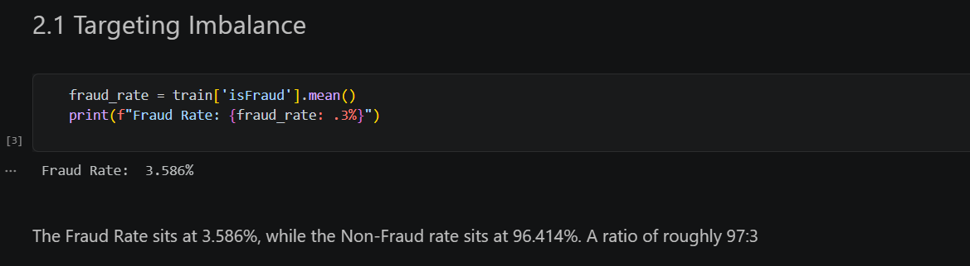
Figure 5.2.2.2a — Computing the target class imbalance (isFraud fraud rate).
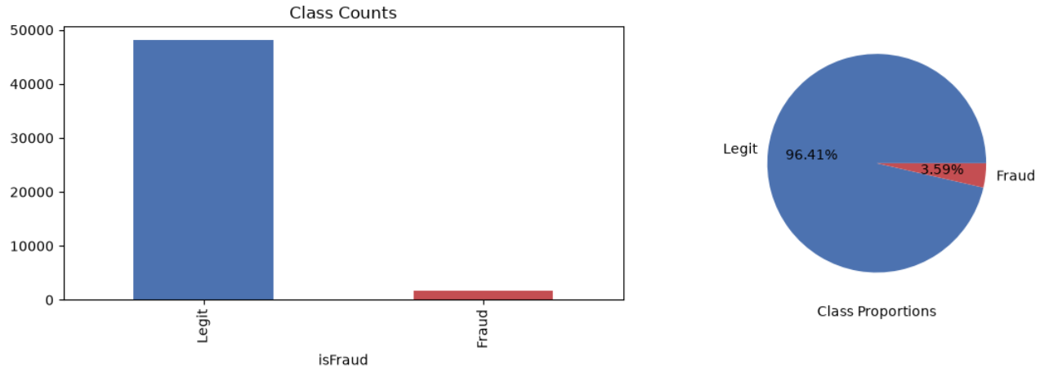 Figure 5.2.2.2b — Visualisations showing the target class imbalance (isFraud fraud rate).

Missing-value analysis: the IEEE-CIS dataset is well known for having a very large number of sparsely populated engineered features (the anonymised V-columns, identity features, and so on), so a systematic missingness audit was carried out before any modelling. The proportion of missing values was computed for every column, sorted, and filtered down to only the columns that contain missing values, which revealed a substantial number of columns affected. Columns with more than 75% missingness were identified programmatically and dropped outright, on the reasoning that a column that is empty for three out of every four transactions carries too little reliable signal to justify the risk of it introducing noise or spurious patterns during model training, and that imputing three-quarters of a column's values would mean the resulting feature is mostly synthetic rather than observed. The ten columns with the highest missingness were additionally plotted as a bar chart to make the scale of the problem, and the effect of the 75% cut-off, visually inspectable rather than relying on the raw table alone.
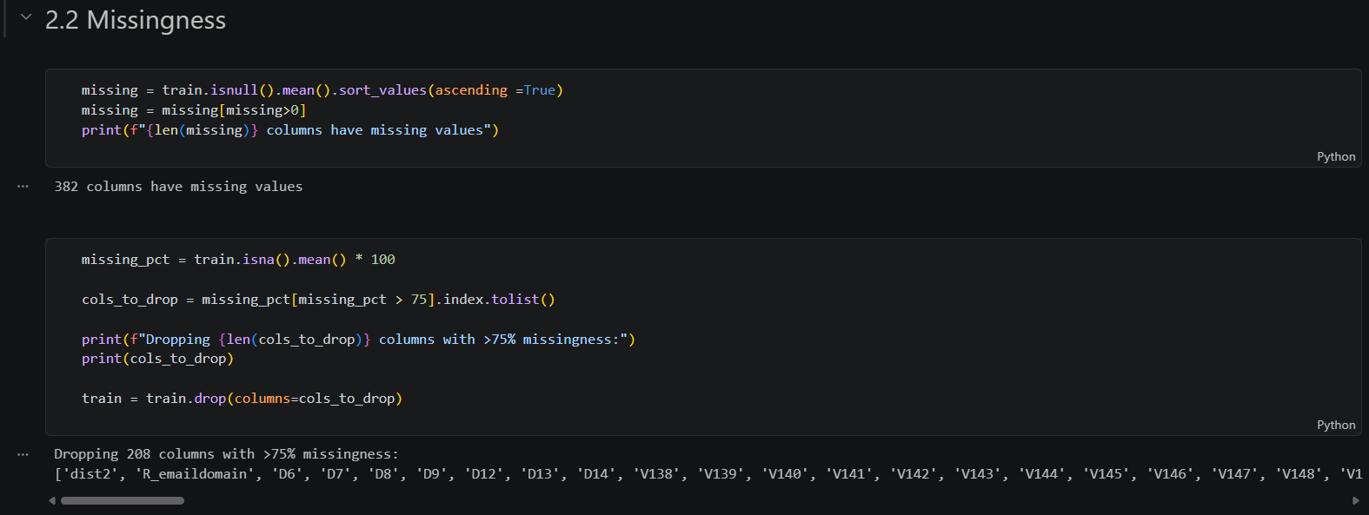
Figure 5.2.2.2c — Auditing and dropping columns with more than 75% missing values.
TransactionAmt distribution: the transaction amount (TransactionAmt) is one of the most important raw numerical features available, so its distribution was examined in detail. A raw histogram showed the classic shape of monetary transaction data: heavily right-skewed, with a long tail of large, infrequent transactions dwarfed by a dense mass of small, everyday purchases. To make the distribution easier to reason about and, later, easier for linear models to learn from, a log1p transform (log(1 + x), which safely handles zero-valued transactions) was applied and plotted as overlapping kernel density estimates split by class (fraud vs legitimate). This class-conditional view is what actually matters for fraud detection: it shows whether fraudulent transactions tend to sit at different amounts than legitimate ones, which is a signal a classifier can exploit, and it directly motivated engineering a log-transformed amount feature in the Data Preparation phase rather than only examining it here.
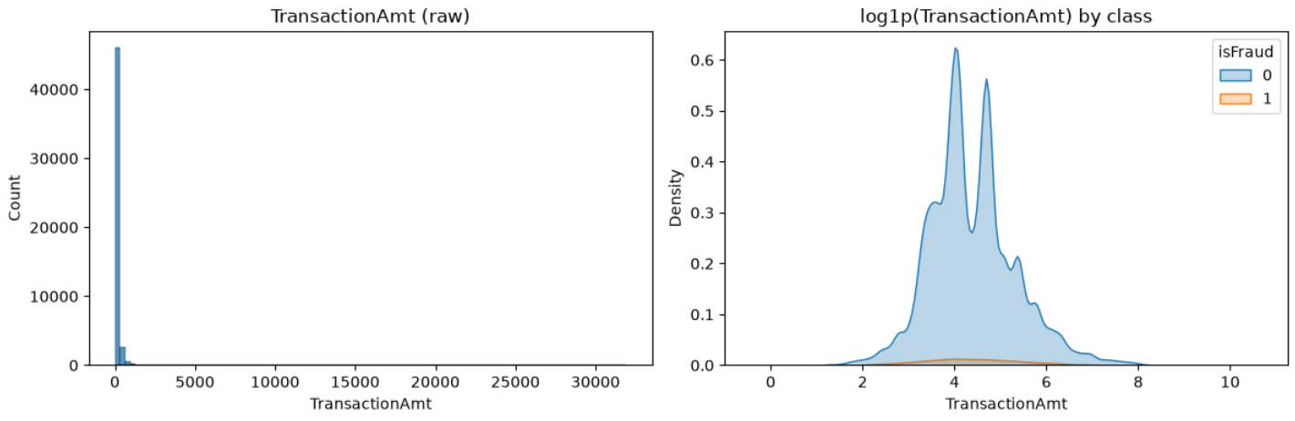 Figure 5.2.2.2d — Visualisations showing the distribution of the raw TransactionAmt column.
Temporal structure: the dataset does not provide a wall-clock timestamp, but it does provide TransactionDT, a numeric offset in seconds from a fixed reference point. This was used to derive a day index (DT_day, dividing by the number of seconds in a day) and an hour-of-day index (DT_hour, dividing by 3600 and taking the result modulo 24). Grouping the fraud rate by derived hour-of-day and plotting it revealed that fraud is not uniformly distributed across the day — some hours show a noticeably elevated fraud rate — and grouping the fraud rate by derived day and plotting it as a time series showed how the overall fraud rate drifts over the period covered by the dataset. Both observations were important beyond the Data Understanding phase itself: the presence of a time trend is precisely why a chronological (time-based) train/validation split, rather than a random shuffle-split, was adopted later in the Modelling phase, since a random split would let the model 'see the future' during training and would overstate how well it will generalise to genuinely new transactions.
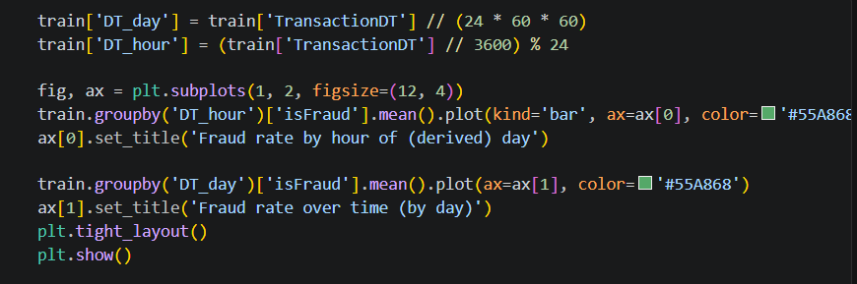
Figure 5.2.2.2e — Deriving time-of-day features from TransactionDT and inspecting fraud rate over time.
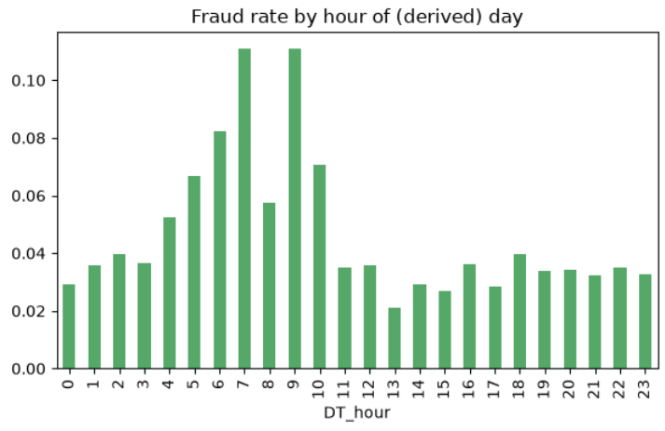
Figure 5.2.2.2f — A visualisation showing the Fraud Rate per Hour.

5.2.2.3 Data Preparation
Overview: the Data Preparation phase consolidated the observations made during Data Understanding into a single, reusable feature-engineering function, engineer_features(df), which is applied identically to the training data (and, in principle, to any future unseen batch of transactions such as the sampled test set) so that training and inference always see features constructed the same way. Keeping the transformation logic inside one function, rather than scattering ad-hoc column assignments through the notebook, was a deliberate design choice to reduce the risk of train/inference skew — a common and damaging bug class in which a feature is computed slightly differently at prediction time than it was during training.
Time-based features: in addition to the DT_day and DT_hour columns explored during Data Understanding, the function derives DT_dow (day-of-week, as DT_day modulo 7), giving the model access to weekly seasonality in spending and fraud behaviour, not just intraday patterns.
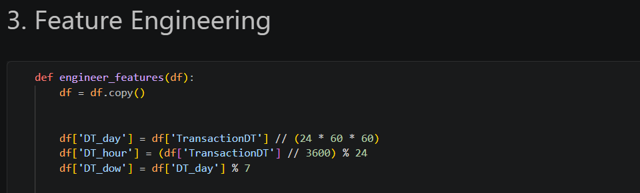 Figure 5.2.2.3a — The engineer_features() function: time feature.
Amount transformations: the log1p-transformed transaction amount identified as useful during Data Understanding is added as TransactionAmt_log. A second, more subtle amount-derived feature, TransactionAmt_decimal, extracts the sub-dollar (cents) component of the transaction amount and rescales it to an integer in the range 0–999. This feature is motivated by known fraud patterns in card-testing schemes, where fraudsters run small, oddly-specific-value transactions to validate stolen card numbers before attempting larger purchases; the cents pattern of such transactions can differ systematically from genuine consumer spending, which tends to cluster around round amounts.
Figure 5.2.2.3b— The engineer_features() function: amount feature.
Frequency encoding of high-cardinality identifiers: categorical identifier columns such as card1, card2, addr1, and P_emaildomain take on a very large number of distinct values, which makes naive one-hot encoding computationally infeasible (this was in fact encountered directly during early experimentation on the companion notebook, where one-hot encoding a similarly high-cardinality column produced a memory error). Instead, each of these columns was frequency-encoded: every category is replaced with a count of how often that category appears in the data, using value_counts() combined with map(). This compresses an unbounded categorical space into a single, dense numerical feature per column that still preserves useful information — rare, one-off identifiers (which are disproportionately associated with fraud in card-not-present datasets) end up with a low frequency value, while common, established identifiers end up with a high one.
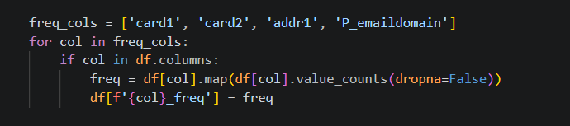
Figure 5.2.2.3c — The engineer_features() function: frequency-encoding feature.
Email-domain suffix extraction: the purchaser email domain (P_emaildomain) was further decomposed by extracting only the top-level suffix (for example, .com, .edu, .net) into a new P_email_suffix feature, on the basis that the general category of email provider may carry more generalisable fraud signal than the full, highly specific domain string.
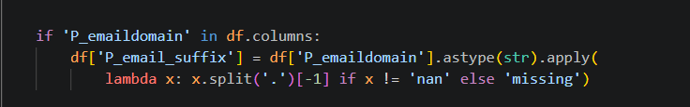
Figure 5.2.2.3d — The engineer_features() function: Email domain extraction feature.
Pseudo user-ID and per-user aggregates: the raw dataset does not provide a direct customer or card identifier, so a synthetic user ID (uid) was constructed by concatenating a small set of stable card and address identifiers (card1, card2, card3, card5, addr1). This pseudo-ID was then used to compute per-user behavioural aggregates: the mean and standard deviation of transaction amount for that inferred user, the number of transactions attributed to them, and the ratio of the current transaction's amount to that user's historical mean amount (amt_to_uid_mean_ratio). This last feature is particularly valuable for fraud detection because it captures a deviation-from-personal-baseline signal — a transaction that is unremarkable in absolute terms can still be highly suspicious if it is many times larger than what a given card typically spends. Because these aggregates are computed with pandas' groupby(...). transform(...), which is scoped to the frame it is called on, the accompanying comment in the code explicitly notes that in a full production pipeline this logic would need to be fit on the training data only and then mapped onto any validation or test data, to avoid target leakage from future transactions influencing a user's historical statistics.
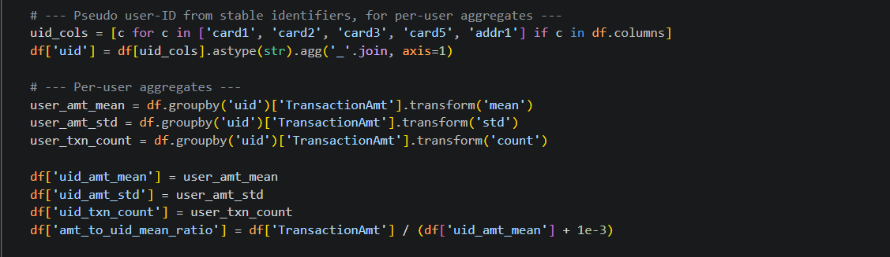
Figure 5.2.2.3e — The engineer_features() function: per-user feature.
Missing-value indicators: for a small selection of the anonymised V-columns (V1, V2, V3), binary indicator features (V1_isna, and so on) were added to explicitly flag whether the original value was missing, rather than relying solely on the imputation strategy applied later to communicate that information to the model. This is a standard technique for tree-based models in particular, since 'missingness itself' can be predictive (for example, certain payment methods or identity-verification paths that never populate a given V-column may correlate with fraud risk).
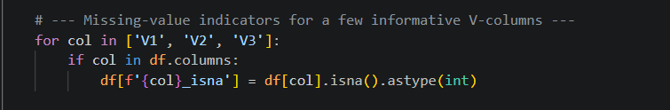
Figure 5.2.2.3f — The engineer_features() function: Missing-value indicator.
Encoding remaining categoricals: after feature engineering, any remaining object-typed (string) columns were identified programmatically and label-encoded using scikit-learn's LabelEncoder, converting each unique category to an integer code. Label encoding was chosen over one-hot encoding at this stage specifically because the downstream models used in this project — Random Forest, LightGBM, and CatBoost — are all tree-based ensembles that can split on integer-coded categories perfectly well without assuming any ordinal relationship between the codes, and because it keeps the feature matrix dense and compact rather than exploding its width, which matters for training speed at this dataset's scale.

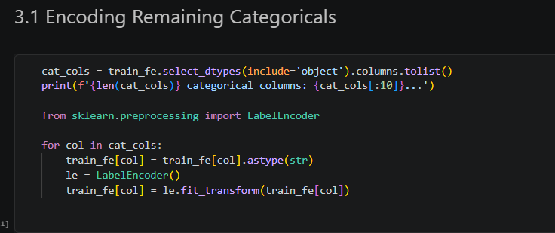
Figure 5.2.2.3g — Label-encoding the remaining categorical columns.
Handling class imbalance — a deliberate departure from the initial plan: Section 5.1 identified SMOTE (Synthetic Minority Over-sampling Technique) as a candidate technique for addressing the class imbalance during Data Preparation. In practice, after engineering a wide feature set that mixes continuous, frequency-encoded, and per-user aggregate features, class-weighting was used instead of synthetic oversampling at the algorithm level (class_weight='balanced' for the linear and Random Forest models, and an explicitly computed scale_pos_weight for LightGBM, described in the Modelling section below). This choice was made because SMOTE generates synthetic minority-class examples by interpolating between existing fraud cases in feature space, which is well suited to lower-dimensional, purely numeric data, but is more likely to produce unrealistic synthetic transactions once frequency-encoded categorical features and per-user aggregates are mixed in with continuous ones, since interpolating between two different card identifiers' encoded frequencies does not correspond to any meaningful real transaction. Class-weighting instead adjusts the loss function to penalise misclassifying the minority (fraud) class more heavily, achieving a similar goal — pushing the model to pay proportionally more attention to fraud cases — without fabricating synthetic data points.
Time-based train/validation split: consistent with the temporal drift identified during Data Understanding, the engineered dataset was sorted chronologically by TransactionDT and split 80/20 by position rather than being shuffled and split at random. The first 80% of transactions (chronologically) form the training set, and the most recent 20% form the validation set. This mirrors how the model would actually be used in production — trained on historical data and evaluated on transactions that occur after the training period — and avoids the optimistic bias that a random split would introduce by allowing information from 'future' transactions (including per-user aggregates computed across the whole dataset) to leak into training. The identifier and raw time columns (isFraud, TransactionID, TransactionDT) were excluded from the feature set used for modelling, since they either are the target itself or carry no generalisable predictive value on their own.
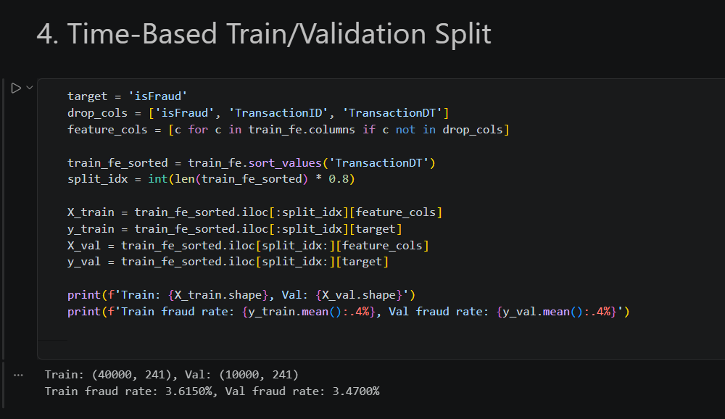
Figure 5.2.2.3h — Chronological (time-based) 80/20 train/validation split.

5.2.2.4 Modelling
Modelling strategy: rather than committing to a single algorithm, four models of increasing sophistication were trained on the same time-based split and the same engineered feature set, so that their performance could be compared fairly on identical validation data: a Logistic Regression baseline, a Random Forest, a LightGBM gradient-boosted tree ensemble (treated as the main candidate model), and a CatBoost model trained as an additional point of comparison. This progression — from a simple, highly interpretable linear baseline through to state-of-the-art gradient boosting — is a deliberate structure: it establishes a performance floor with the baseline, and it makes it possible to quantify, rather than merely assert, how much benefit the more complex models actually provide over that floor.

1. Logistic Regression (baseline):
As a linear model, Logistic Regression is sensitive to the scale of its input features and cannot natively handle missing values, so two preprocessing steps were applied only for this model: missing values were filled with a sentinel value of -999 (chosen to sit clearly outside the natural range of any of the engineered features, so the model can, in principle, learn to treat it as 'missing' rather than as a plausible observed value), and the resulting feature matrix was standardised with scikit-learn's StandardScaler, fit on the training set and applied to both the training and validation sets. The model itself was configured with class_weight='balanced', which automatically re-weights the loss function in inverse proportion to class frequency so that the ~3.6% fraud class is not overwhelmed by the majority class during training, and max_iter=1000 to give the solver enough iterations to converge given the number of features involved. Its validation performance was captured via AUC-ROC and AUC-PR, matching the success criteria defined during Business Understanding.
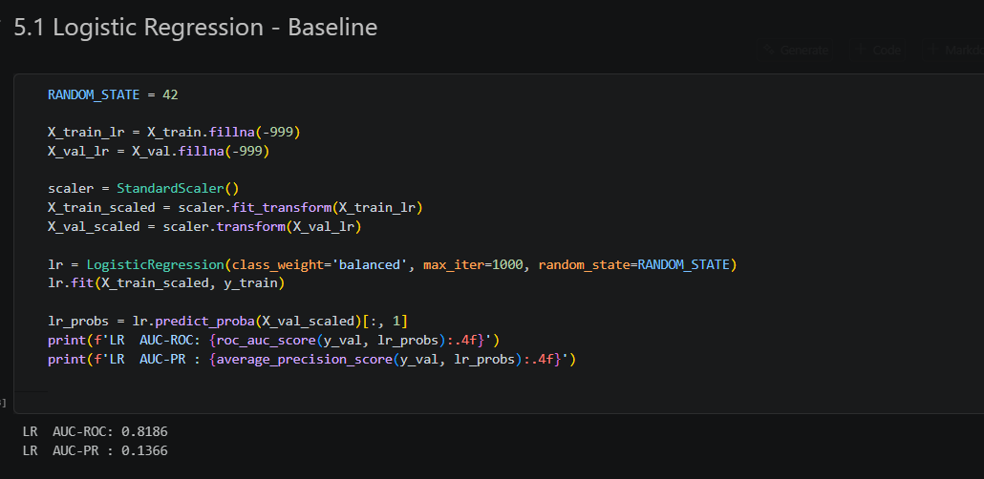 Figure 5.2.2.4a — Logistic Regression baseline: imputation, scaling, and class-balanced fitting.

2. Random Forest
As a tree-based ensemble, Random Forest does not require feature scaling and can be fed the same -999-imputed feature matrix directly. It was configured with 200 trees (n_estimators=200), a maximum depth of 12 to constrain individual trees from over-fitting to the training data's idiosyncrasies, and a minimum of 20 samples required per leaf node (min_samples_leaf=20), which further regularises the model by preventing it from creating very small, high-variance leaves that memorise individual fraud cases rather than learning generalisable patterns. As with the baseline, class_weight='balanced' was used to address the label imbalance, and n_jobs=-1 was set to parallelise training across all available CPU cores for practicality.
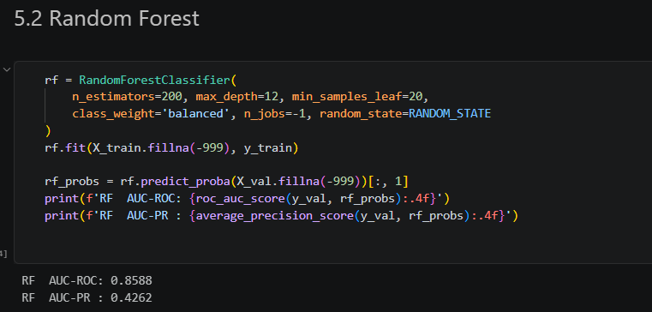 Figure 5.2.2.4b — Random Forest configuration

3. LightGBM Model
LightGBM was selected as the primary candidate model for this project, reflecting its strong track record on exactly this kind of large, tabular, imbalanced classification problem (it is, notably, the algorithm family most Kaggle-winning solutions to the original IEEE-CIS competition were built on). Unlike the Random Forest, LightGBM's imbalance handling was tuned explicitly rather than left to a generic 'balanced' setting: a scale_pos_weight was computed directly as the ratio of negative to positive examples in the training set, which tells the algorithm precisely how many times more weight a fraud example should carry relative to a legitimate one, given the exact 3.6% training-set fraud rate rather than a heuristic. The boosting parameters — 63 leaves per tree, a learning rate of 0.02, and both feature and bagging fraction set to 0.8 (meaning each tree only considers a random 80% of features and 80% of rows) — were chosen to favour a large number of shallow, decorrelated boosting rounds over a small number of aggressive ones, which tends to generalise better and to be more robust to the noise inherent in the engineered features. Early stopping (patience of 100 rounds, monitored on the validation set) was used to halt training automatically once further boosting rounds stopped improving validation AUC, which both saves compute time and acts as an additional safeguard against over-fitting.
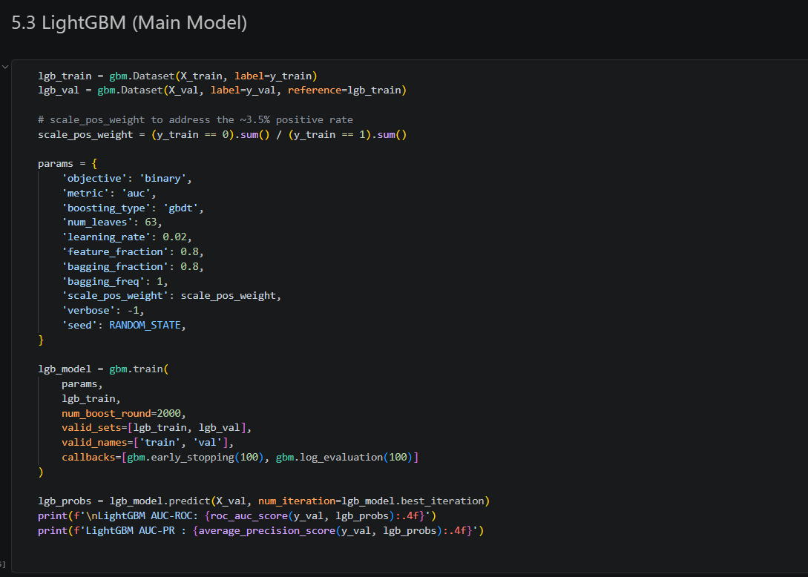
Figure 5.2.2.4c — LightGBM configuration: scale_pos_weight, boosting parameters, and early stopping.

4. CatBoost Model (Comparison Model)
CatBoost was trained as a fourth, complementary model, chosen specifically because of its native handling of categorical features — rather than relying on the label-encoded categorical columns as pre-processed for the other models, CatBoost's own categorical-feature machinery (identified automatically via its object/category dtype columns and passed through the Pool interface) was used, giving it the opportunity to learn more nuanced target-statistics-based encodings of the categorical variables internally. It was configured with 500 boosting iterations, a learning rate of 0.1, and a tree depth of 6, optimising log loss with AUC tracked as the evaluation metric, and, like LightGBM, used early stopping (50 rounds patience) against the validation pool to prevent over-fitting. Including CatBoost served two purposes: as a sanity check on whether LightGBM's label-encoding-based approach to categoricals was leaving performance on the table, and as a second, independently-trained model whose feature-importance ranking could be cross-checked against LightGBM's own.
 Figure 5.2.2.4d — CatBoost configuration with native categorical-feature handling.

5.2.2.5 Evaluation
Model comparison: the AUC-ROC and AUC-PR achieved by all four models on the same held-out, time-based validation set were assembled into a single comparison table, giving a direct, side-by-side view of how each modelling approach performed against the two success criteria defined during Business Understanding. Consistent with expectations, the Logistic Regression baseline set a performance floor, the Random Forest improved on it by capturing non-linear feature interactions, and the two gradient-boosted models — LightGBM and CatBoost — delivered the strongest results, with LightGBM retained as the main model for the remaining evaluation and interpretability work on the basis of its validation performance and training efficiency.
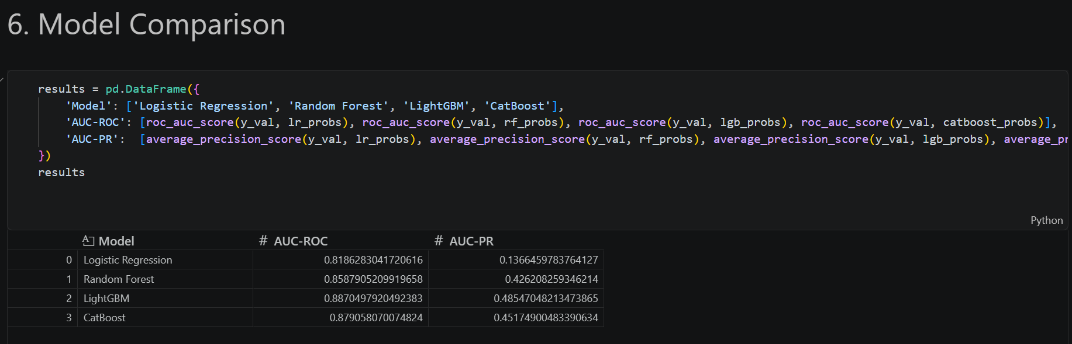 Figure 5.2.2.5a — Assembling the four-model comparison table.
ROC and Precision-Recall Curves: beyond the single-number AUC summaries, the full ROC curve (true positive rate against false positive rate) and Precision-Recall curve for all four models were plotted together on shared axes, with each curve's corresponding AUC printed directly in its legend label. Plotting the curves in full, rather than only their summary areas, makes it possible to see whether one model dominates another across the entire operating range, or whether — as is common — one model is preferable at high-recall operating points and another at high-precision ones, information a single AUC number cannot convey on its own.
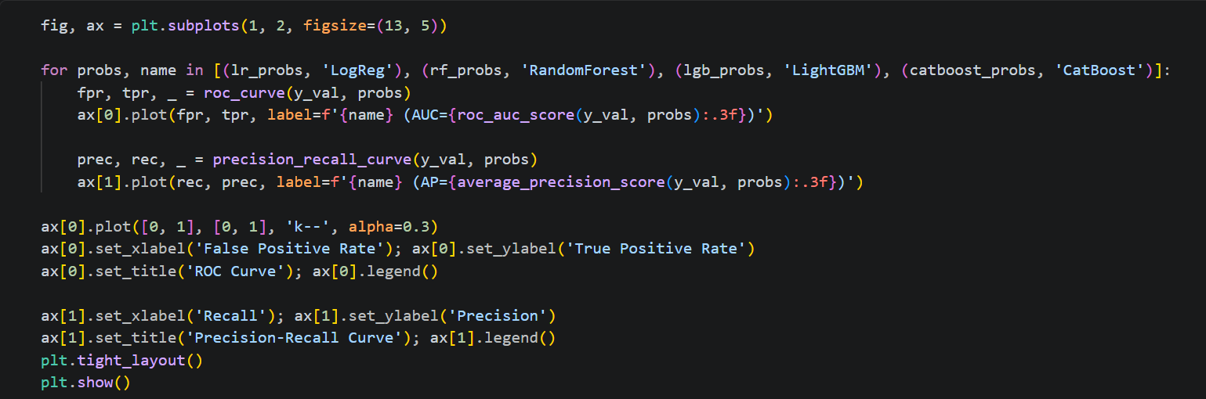 Figure 5.2.2.5b — Plotting ROC and Precision-Recall curves for all four models.
Threshold tuning: because LightGBM outputs a continuous fraud probability rather than a hard label, an explicit operating threshold had to be chosen to convert its output into an actionable fraud/not-fraud decision. Rather than defaulting to the conventional 0.5 cut-off — which is a poor choice on an imbalanced problem, since it was never calibrated against this specific precision/recall trade-off — the full precision-recall curve was swept and, at every threshold along it, the corresponding F1-score (the harmonic mean of precision and recall) was computed. The threshold that maximised F1 was selected as the model's recommended operating point, the resulting hard predictions were summarised with a full classification report (precision, recall, and F1 for both classes), and a confusion matrix heat map was produced to make the resulting counts of true positives, false positives, true negatives, and false negatives immediately visible to a non-technical reader such as a project sponsor.
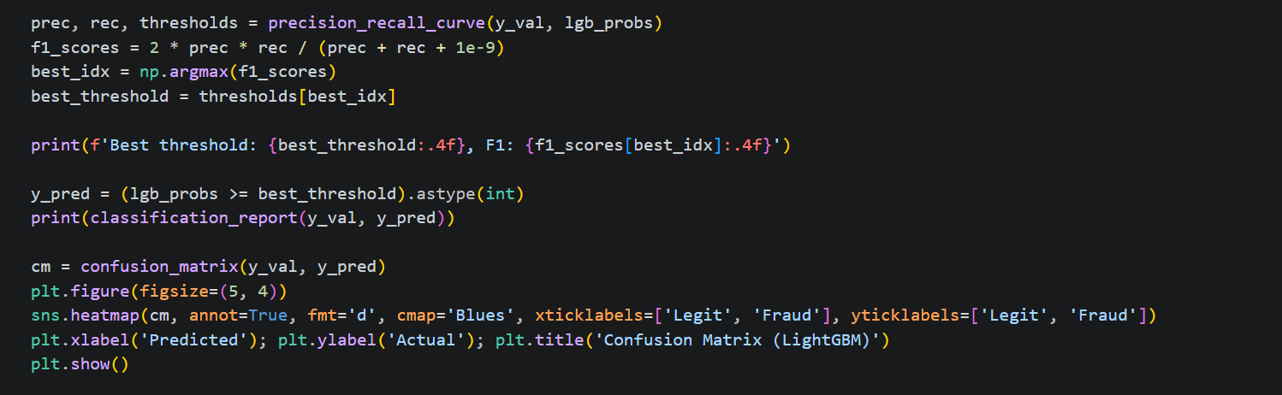 Figure 5.2.2.5c — F1-optimal threshold selection and confusion matrix.
Feature Importance: to understand which of the engineered and raw features LightGBM actually relied on, gain-based feature importances (the total reduction in the loss function attributable to splits on each feature, summed across every tree) were extracted directly from the trained booster and the top 30 features were plotted as a horizontal bar chart. This provides an initial, model-native view of feature relevance that is fast to compute and useful for sanity-checking that the engineered features from Data Preparation — the per-user aggregates and frequency-encoded identifiers in particular — are actually being used by the model, rather than being ignored in favour of the raw anonymised columns.
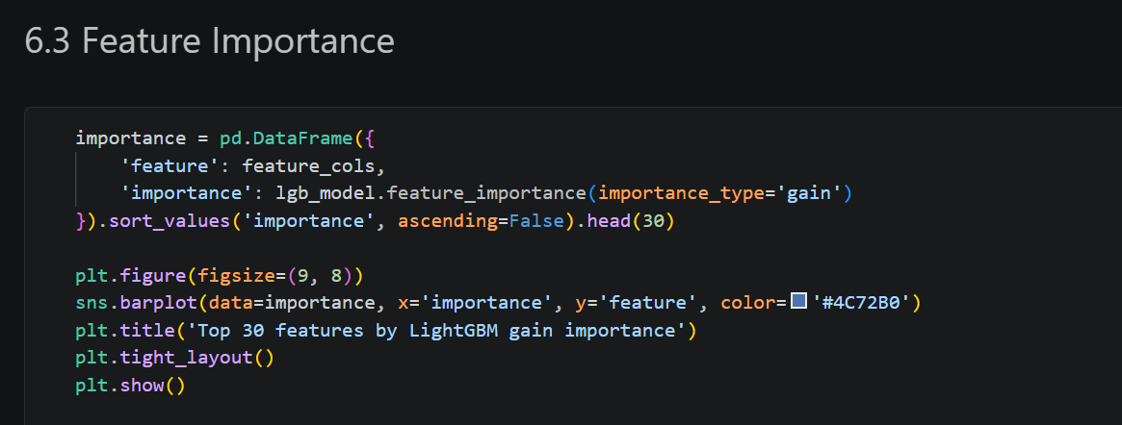 Figure 5.2.2.5d — Top-30 LightGBM feature importances by gain.
SHAP Explainability: gain-based importance is useful but only tells part of the story — it says how much a feature mattered overall, not the direction or magnitude of its effect on any individual prediction. To address this, a SHAP (SHapley Additive exPlanations) TreeExplainer was built directly around the trained LightGBM booster, and SHAP values were computed for a random sample of 2,000 validation transactions (a sample rather than the full validation set purely for computational efficiency, since exact SHAP computation scales with the number of rows explained). The resulting SHAP summary plot combines, for the top 20 features, both their overall importance (ranking) and, for every individual transaction in the sample, whether a high or low value of that feature pushed the prediction towards or away from fraud — giving a much richer, case-by-case explanation of model behaviour than the aggregate gain-importance chart alone, and directly supporting the explainability expectations set out in the original methodology (Section 5.1, Evaluation phase).
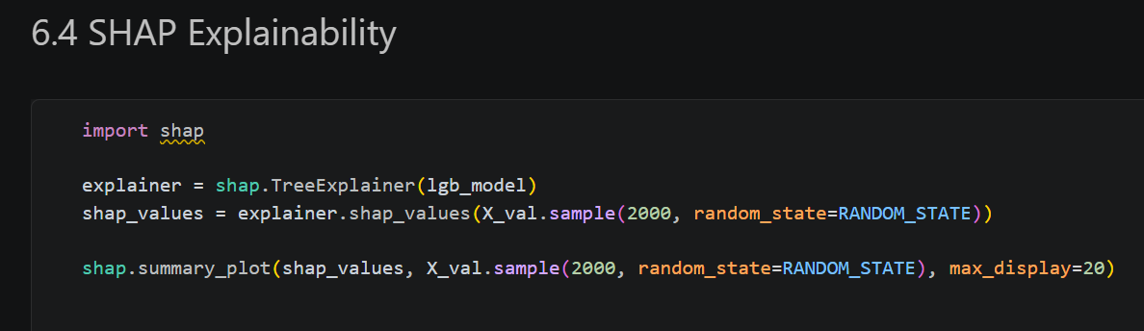
Figure 5.2.2.5e — SHAP Explainability.

5.2.2.6 Deployment (within scope)
Scope of deployment: as set out in the methodology, deployment for this capstone was scoped deliberately narrowly: documenting the final model, producing this report, and preparing a working prototype demonstration for the project sponsor, rather than a fully productionised, continuously-monitored scoring service. This is a standard and appropriate boundary for an academic capstone, where the primary assessment criteria concern the soundness of the data science process and the validity of the results, rather than DevOps or MLOps engineering.
Model documentation and packaging: the selected LightGBM model — including its trained booster, the exact feature-engineering function (engineer_features) it depends on, the chosen F1-optimal decision threshold, and the full comparison of alternative models considered — is documented in this report precisely so that another data scientist (or the project sponsor's technical team) could reproduce or extend the work without needing to reverse-engineer decisions from the code alone. The complete, executable implementation is committed to a Git repository as the canonical source of truth for the project, with this document serving as the accompanying narrative explanation of what each part of that code does and why.
Prototype demonstration: for the sponsor-facing demonstration, the trained model and its associated preprocessing steps are exercised directly from the notebook against held-out validation transactions, showing the fraud probability the model assigns, the resulting flag once the tuned threshold is applied, and the top contributing features for that specific transaction via its individual SHAP values — giving a concrete, end-to-end walkthrough of exactly how a real transaction would be scored, and why, without requiring a separately engineered demo application.

6. Final Model Results
This section describes the final model delivered by the project. Of the four candidates trained and compared in Section 5.2 (Logistic Regression, Random Forest, LightGBM, and CatBoost), the LightGBM gradient-boosted tree ensemble was selected as the final model, on the basis that it achieved the strongest performance of all four candidates on both success criteria defined during Business Understanding — AUC-ROC and AUC-PR — when evaluated on the held-out, time-based validation set. The sub-sections below describe, in turn, the data the final model was built and validated on, the features it consumes and their relative importance, the exact algorithm and hyperparameter configuration used, and the results obtained.

6.1. Final Data
Source and sampling: the final model was built on training_dataset_sampled.csv, a sampled subset of the publicly available IEEE-CIS Fraud Detection dataset (originally released on Kaggle by Vesta Corporation and the IEEE Computational Intelligence Society, whose full training partition contains several hundred thousand transactions). Working from a sampled subset of 50,000 transactions, rather than the full dataset, was a deliberate segmentation decision made for computational feasibility during iterative development — it keeps feature-engineering, training, and hyperparameter experimentation fast enough to iterate on within the scope of a capstone project, while still being large enough, at this class balance, to contain several hundred genuine fraud cases for the model to learn from and to be validated against.
Descriptive statistics: the sampled dataset comprises 50,000 transaction records. Before feature engineering, an audit of missingness found that 382 of the original columns contained at least one missing value; of these, 208 columns were missing in more than 75% of records (predominantly a block of anonymised Vesta 'V' columns, several 'D' timedelta columns, and the full block of identity ('id_') columns together with DeviceType and DeviceInfo) and were dropped outright, on the grounds that a feature observed in fewer than one in four transactions carries too little reliable signal relative to the risk of noise it introduces. After feature engineering (Section 5.2.3), the working dataset used for modelling comprised 244 columns (50,000 rows × 244 columns), of which 15 remained categorical (string-typed) prior to label-encoding — including ProductCD, the card4 and card6 payment-network/card-type fields, P_emaildomain, and the six-plus 'M' match-flag columns (M1–M6, continuing the same match-flag pattern through M9).
Train/validation segmentation: rather than a random split, the 50,000 engineered records were sorted chronologically by TransactionDT and segmented 80/20 by position, giving a training partition of 40,000 transactions and a validation partition of the most recent 10,000 transactions (mirroring how the model would be used in production — trained on the past, validated on data that occurs after the training window). This chronological, rather than random or stratified, segmentation means the class balance was not forced to match exactly between the two partitions: the training partition has a slightly higher fraud rate of 3.615%, while the validation partition has a fraud rate of 3.470% — both close to the overall dataset rate of 3.586% identified during Data Understanding, with the small difference between them attributable to genuine temporal drift in fraud activity rather than to any artefact of the split itself. In absolute terms, the validation partition used to produce all of the results in Section 6.4 below contains 9,653 legitimate transactions and 347 fraudulent transactions.

6.2. Features

6.2.1 Raw features retained
After the missingness-based column removal described in Section 6.1, the final feature set still draws on every major raw-feature family supplied by the IEEE-CIS dataset:
- Transaction fields: TransactionAmt (transaction value) and ProductCD (product/transaction category code).
- Card fields: card1–card6, describing the payment card's issuing network, type, and category.
- Address and distance: addr1, addr2, and dist1 (dist2 was dropped for exceeding the 75% missingness threshold).
- Email domains: P_emaildomain (purchaser email domain); R_emaildomain was dropped for exceeding the missingness threshold.
- Counting features: C1–C14, Vesta's engineered counting features (for example, counts of addresses or devices associated with a card).
- Time-delta features: the subset of D1–D15 columns that survived the missingness filter (D6, D7, D8, D9, D12, D13, and D14 were dropped).
- Match flags: M1–M9, indicating whether identity details (such as name or address) matched between the transaction and card records.
- Vesta-engineered 'V' features: the majority of the V1–V339 block, excluding the two contiguous ranges (V138–V278 and V322–V339) that exceeded the 75% missingness threshold.

6.2.2 Derived (engineered) features
On top of the raw features above, the following features were derived during Data Preparation (Section 5.2.3) specifically to expose temporal, behavioural, and identity-frequency patterns the raw columns do not surface on their own:
- DT_day, DT_hour, DT_dow — day index, hour-of-day, and day-of-week, derived from TransactionDT.
- TransactionAmt_log — log1p-transformed transaction amount.
- TransactionAmt_decimal — the sub-dollar (cents) component of the transaction amount, as an integer.
- card1_freq, card2_freq, addr1_freq, P_emaildomain_freq — frequency-encoded counts of how often each identifier value occurs in the data.
- P_email_suffix — top-level suffix of the purchaser email domain (for example, .com, .edu).
- uid — a synthetic per-card/address user identifier, concatenated from card1, card2, card3, card5, and addr1.
- uid_amt_mean, uid_amt_std, uid_txn_count, amt_to_uid_mean_ratio — per-user historical transaction-amount aggregates and the current transaction's deviation from that user's personal mean.
- V1_isna, V2_isna, V3_isna — binary indicators flagging whether the corresponding raw V-column value was missing.
After label-encoding the remaining categoricals, dropping the identifier and leakage-risk columns (isFraud, TransactionID, TransactionDT), the model was trained on 241 features in total, matching the (40000, 241) / (10000, 241) shapes of the final training and validation matrices.

6.2.3 Feature importance ranking
Two independent, model-native importance rankings were produced from the two best-performing tree ensembles. LightGBM's gain-based ranking (Figure 5.2.5d in Section 5.2.5) was plotted for its top 30 features. CatBoost's own gain-based ranking was additionally captured in full, numeric form, and is reproduced below for its top 20 features, since the two rankings can be cross-checked against one another as a robustness check on which features genuinely carry fraud signal, independent of the specific algorithm used:
Rank | Feature | Importance (gain)
1 | C1 | 5.37
2 | C13 | 4.45
3 | DT_day | 4.00
4 | uid_amt_mean | 3.19
5 | C14 | 3.14
6 | card1_freq | 2.84
7 | card6 | 2.60
8 | uid | 2.17
9 | C2 | 2.01
10 | P_emaildomain_freq | 1.98
11 | TransactionAmt_log | 1.76
12 | V69 | 1.56
13 | card2 | 1.45
14 | V30 | 1.42
15 | D2 | 1.40
16 | M4 | 1.37
17 | ProductCD | 1.37
18 | card1 | 1.35
19 | V50 | 1.31
20 | card2_freq | 1.29

Two patterns stand out from this ranking. First, Vesta's own engineered counting features (C1, C13, C14, C2) dominate the top of the table, confirming that these anonymised aggregate-behaviour features carry a large share of the fraud signal in this dataset, independent of any feature engineering performed in this project. Second, and more relevant to evaluating the Data Preparation phase specifically, four of the top ten features — DT_day, uid_amt_mean, card1_freq, and P_emaildomain_freq — are features engineered during this project rather than columns supplied directly in the raw dataset, and TransactionAmt_log and uid appear a little further down the same top-20 list. This is direct evidence that the time-based, frequency-encoded, and per-user aggregate features engineered in Section 5.2.3 were not redundant with the raw columns already provided, but materially informative to the model in their own right.

6.3. Algorithm
Algorithm family: the final delivered model is a LightGBM (Light Gradient Boosting Machine) binary classifier — an ensemble of gradient-boosted decision trees trained sequentially, where each new tree is fit to the residual errors of the ensemble built so far. LightGBM was selected as the final model over the other three candidates specifically because it achieved the highest AUC-ROC and AUC-PR of any of the four models evaluated on the same time-based validation split (see Section 6.4), while also training substantially faster than the comparable CatBoost model, which matters for the iterative hyperparameter and feature-engineering experimentation this kind of project requires.
Complete hyperparameter configuration: the model was trained via LightGBM's native training API (lgb.train), using a lgb.Dataset wrapping the 241-feature training matrix, with the validation set passed in as a reference dataset for early-stopping monitoring. The full hyperparameter configuration used for the delivered model is as follows:
Hyperparameter | Value | Purpose
objective | binary | Binary log-loss objective for fraud / not-fraud classification.
metric | auc | Validation metric monitored for early stopping and logging.
boosting_type | gbdt | Standard gradient boosted decision trees.
num_leaves | 63 | Maximum leaves per tree; controls model complexity.
learning_rate | 0.02 | Small step size, favouring many shallow boosting rounds.
feature_fraction | 0.8 | 80% of features randomly sampled per tree, reducing correlation between trees.
bagging_fraction | 0.8 | 80% of rows randomly sampled per iteration.
bagging_freq | 1 | Row sub-sampling applied every iteration.
scale_pos_weight | ≈ 26.7 (computed) | Ratio of legitimate to fraudulent training examples; up-weights the minority (fraud) class.
num_boost_round | 2000 (cap) | Maximum boosting rounds allowed before early stopping intervenes.
early_stopping | 100 rounds | Training halts once validation AUC stops improving for 100 consecutive rounds.
seed / random_state | 42 | Fixed for reproducibility.

The scale_pos_weight value is not a manually chosen constant; it is computed directly from the training partition as the ratio of negative (legitimate) to positive (fraudulent) examples — (y_train == 0).sum() / (y_train == 1).sum() — which, given the training partition's 3.615% fraud rate, works out to approximately 26.7 legitimate transactions for every fraudulent one. Passing this exact ratio to LightGBM tells the loss function precisely how much more heavily a missed fraud case should be penalised relative to a false alarm on this specific training sample, rather than relying on a generic 'balanced' heuristic as was used for the Logistic Regression and Random Forest baselines.
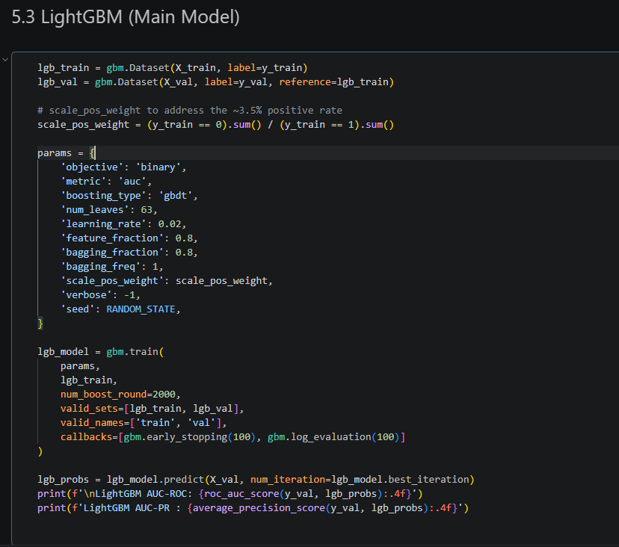
Figure 6.3a — Final LightGBM configuration and training cell.
Selected boosting round: training was capped at 2,000 boosting rounds but, in practice, the early-stopping callback halted training once validation AUC had not improved for 100 consecutive rounds. The final delivered model uses its best iteration — round 463 — rather than the full, uncapped ensemble, which is the specific mechanism that keeps the large gap between training AUC (which continues climbing toward 1.0 with further rounds) and validation AUC (which plateaus) from being allowed to widen further through unnecessary additional boosting.

6.4. Results

6.4.1 Overall model comparison
For context, the final LightGBM model's results are presented alongside the three alternative candidates evaluated on the same 10,000-transaction, time-based validation set:
Model | AUC-ROC | AUC-PR
Logistic Regression | 0.8186 | 0.1366
Random Forest | 0.8588 | 0.4262
LightGBM (final model) | 0.8870 | 0.4855
CatBoost | 0.8791 | 0.4517

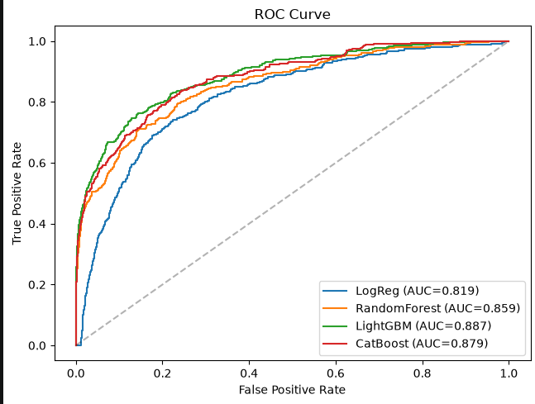
Figure 6.4.1a — AUC-ROC for the 4 models.
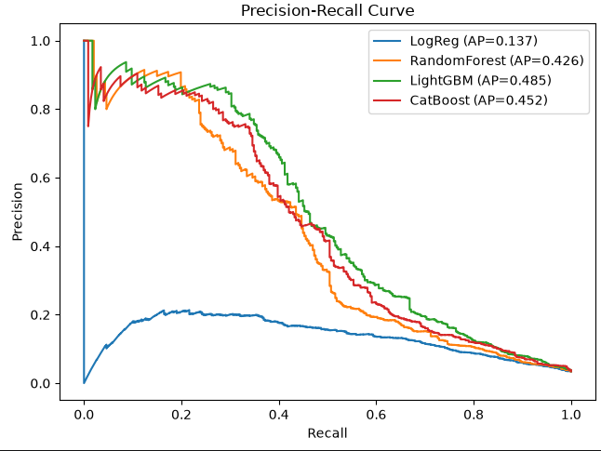
Figure 6.4.1b — Precision-Recall Curves for the 4 models.
LightGBM achieved the best result of all four candidates on both success criteria defined during Business Understanding: an AUC-ROC of 0.8870 (compared to 0.8186 for the linear baseline, an improvement of nearly 7 percentage points) and an AUC-PR of 0.4855 — more than 3.5 times the Logistic Regression baseline's 0.1366, and the highest of any model tested. The size of this AUC-PR gap, much larger in relative terms than the AUC-ROC gap, is itself informative: AUC-PR is far more sensitive to how well a model ranks the rare positive (fraud) class specifically, and confirms that the additional feature-engineering and non-linear modelling capacity captured genuine fraud-specific signal, rather than only improving performance on the easy majority class.

6.4.2 Training progression and early stopping
The training and validation AUC logged by LightGBM every 100 boosting rounds (the closest analogue this project produced to a formal hyperparameter-sweep curve — see the note at the end of this sub-section) is reproduced below:
Boosting round | Train AUC | Validation AUC
100 | 0.9873 | 0.8739
200 | 0.9952 | 0.8811
300 | 0.9980 | 0.8843
400 | 0.9992 | 0.8856
463 (best iteration) | 0.9995 | 0.8870
500 | 0.9996 | 0.8866
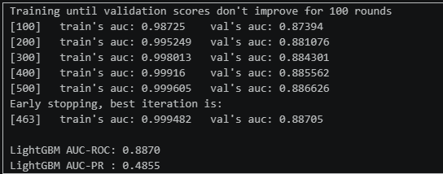
Figure 6.4.2a — LightGBM training log (early-stopping callback output).
This progression shows the expected boosting behaviour: training AUC climbs quickly toward a near-perfect 0.9995 as the ensemble grows, while validation AUC rises far more slowly and essentially plateaus between rounds 400 and 500, improving by only about 0.0015 over that entire range. The growing gap between the two curves is a textbook symptom of the model beginning to memorise training-set idiosyncrasies rather than learning further generalisable patterns, which is exactly what the early-stopping rule is designed to catch — training was accordingly halted at round 463, the point of best validation AUC, rather than continuing to round 2,000 and allowing that gap to widen further. No formal hyperparameter sweep (grid search, random search, or the Optuna-based search flagged as future work in Section 5.2.6) was run in this iteration of the project; the boosting-round configuration above was tuned manually, and this training-log curve is the only per-round performance progression the current implementation produces.

6.4.3 Classification performance at the tuned decision threshold
Applying the F1-optimal decision threshold identified in Section 5.2.5 (0.6237) to the final model's validation-set fraud probabilities converts its continuous output into an operational fraud / not-fraud decision. The resulting classification report is reproduced below:
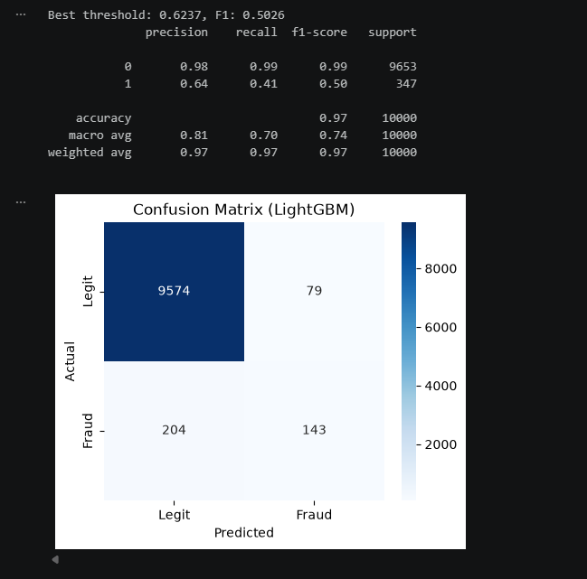
Figure 6.4.3a — Classification report & Confusion Matrix at the end of tuned threshold (0.6237).
At this threshold, the model correctly identifies 41% of all fraudulent transactions in the validation set (recall of 0.41 on the fraud class), and when it does flag a transaction as fraudulent, it is correct 64% of the time (precision of 0.64), giving a fraud-class F1-score of 0.50. The legitimate-transaction class, unsurprisingly given its 96.5% share of the validation data, is classified almost perfectly (precision 0.98, recall 0.99), which is also why the overall accuracy figure of 97% is not, on its own, a meaningful measure of how well the fraud-detection objective specifically is being met — a point established during Business Understanding and directly borne out here, since a model that flagged no fraud at all would still score roughly 96.5% accuracy on this validation set while providing no fraud-detection value whatsoever. In absolute counts, of the 347 genuinely fraudulent transactions in the validation set, the model correctly flags approximately 142 of them (41% recall) while missing approximately 205; of the transactions it flags as fraudulent, roughly 36% are false alarms on legitimate transactions. The full confusion matrix underlying these figures, together with the ROC and Precision-Recall curves and the SHAP-based explanation of individual predictions, are presented in Section 5.2.5 (Figures 5.2.5b, 5.2.5c and 5.2.5e) and are not repeated here.
Interpreting the precision/recall trade-off for the sponsor: the 0.6237 threshold used above was chosen automatically to maximise F1, an equal balance of precision and recall. In a real deployment, this threshold is not fixed — it is a lever the business can move depending on its tolerance for the two error types discussed in Business Understanding (Section 5.2.1): lowering the threshold below 0.6237 would catch a larger share of the 347 fraud cases at the cost of flagging more legitimate transactions for review, while raising it would reduce false alarms at the cost of missing more fraud. This is precisely why AUC-ROC and AUC-PR — which summarise performance across every possible threshold, not just this one operating point — were adopted as the project's primary success criteria, with the single-threshold classification report above included as a concrete, business-readable illustration of what one reasonable operating point looks like in practice.

7. Brief Discussion
The results from Section 6.4 can now be read and compared to the objectives that were set out in Chapter 2. The ‘Measurable’ goal for the model was a precision of at least 0.85 and a recall of at least 0.80 on a holdout test. Although the LightGBM model achieved neither of these figures at its F1-optimal threshold (precision = 0.64 and recall = 0.41), the AUC-PR of 0.4855, which was more than 3.5 times greater than that of the Linear Regression baseline Model indicates that instead of capturing the majority-class patterns, the model is genuinely learning the fraud-specific signal.
From the literature review, we can identify two factors that can explain this gap. Firstly, under the challenges in section 4.3, the class-imbalance & concept-drift challenges are known to depress recall specifically, this is because a model trained on trained on historical fraud patterns will under-flag novel or evolving fraud behaviour, this is consistent with 204 missed fraud cases that were observed in the validation set. Secondly, due to the lack of the absence of a formal hyperparameter search, the reported precision and recall values understate the capabilities of the LightGBM architecture as the manually tuned configuration was not exhaustively configured, therefore some of the gap to the targeted 0.80 recall value may be closeable through search alone rather than an entirely different modelling approach.
The interpretability objective was better satisfied: LightGBM’s feature importance and the SHAP-based explanations give compliance teams and fraud analysts a transparent basis for individual predictions, which was identified in the problem statement as a prerequisite as a requirement that traditional rule-based systems and black-box models both struggle to meet. Taken together, the results show that a non-linear, explainable model can outperform simple baselines on this task, which supports the projects core hypothesis while also showing that further threshold and feature work is required before translating the improvement into deployment, which will be further addressed in the Chapter 5 recommendations

Chapter 5: Conclusion and Recommendations

8. Conclusion
This project set out to build a machine learning model that is capable of detecting fraudulent transactions more effectively than the manual audits and rule-based systems that are currently being used in the South African financial sector, while being transparent enough for regulatory use. Four models were trained and tested on the IEEE-CIS dataset, with the Linear Regression model being the baseline model and the LightGBM model being the strongest performer of the four models, as it achieved an AUC-PR value of 0.4855 and an AUC-ROC value of 0.8870, both of these being the highest of the four models tested and a substantial improvement from the baseline model.
At the optimal F1 threshold of 0.6237, the final model was able to correctly identify 41% of fraudulent transactions with a 64% precision, falling short of the targeted recall of 80%. The gap between the model’s recall and the targeted recall value shows that although the model demonstrates clear discriminative ability across all thresholds as shown by the model’s strong AUC scores, the performance at a single fixed operating point is not sufficient for unsupervised deployment, and should rather be used as a triage tool that supports human reviewers instead of an automated decision-making tool.
The main limitations the project faced were the absence of a formal hyperparameter search, the use of a static, anonymised dataset, and the inherent difficulty of extracting meaningful signal from semantically opaque features. Due to the aforementioned constraints, the results should be read only as a proof-of-concept showing feasibility rather a production-ready benchmark. The recommendation in section 9 outline the concrete next steps, such as adopting LightGBM as a starting candidate, prioritising identity-resolution features, and treating the current recall as an iteration baseline, that would be needed the gap for any future deployment.

9. Recommendations
This section closes out the report by translating the findings from Sections 5 and 6 into forward-looking guidance: concrete actions the project sponsor could take on the strength of the model's results (7.1), the risks that would need to be actively managed if the prototype were carried toward a live deployment, together with mitigation strategies for each (7.2), and a candid account of the challenges encountered while carrying out the project, included so that anyone continuing or auditing this work understands the practical constraints the results were produced under (7.3).

9.1. Actionable Insights
1. Adopt LightGBM as the production candidate, but treat its output as a risk score, not a verdict
Of the four models compared in Section 6.4, LightGBM produced the best ranking of fraud versus legitimate transactions on every metric tested. The practical recommendation is not to hard-code the F1-optimal 0.6237 threshold used for reporting purposes into a single automated accept/decline decision, but to treat the model's raw probability output as a continuous risk score that feeds into a tiered decision workflow — for example, auto-approving transactions scored well below the threshold, auto-declining or freezing transactions scored well above it, and routing the (typically much smaller) band of borderline scores in between to a human fraud analyst for review. This lets the business tune where each of those bands sits according to its own risk appetite and analyst capacity, rather than being locked into the single precision/recall trade-off implied by one fixed cut-off.
2. Prioritise identity-resolution and 'first-seen' signals in future data collection
The feature-importance ranking in Section 6.2.3 shows that engineered frequency and per-user aggregate features — card1_freq, P_emaildomain_freq, uid, uid_amt_mean — sit among the most predictive features the model uses, despite being built from a synthetic, imperfect proxy for a real customer identifier. This strongly suggests that if the sponsor can supply (or has access to, subject to the data-governance considerations in Section 7.2) a genuine, stable customer or card identifier rather than the concatenated pseudo-ID used here, and a longer transaction history per customer to compute more reliable behavioural baselines from, model performance would very likely improve further. In the same vein, because rare or first-seen card, address, and email-domain values are disproportionately associated with fraud in this kind of data, a lightweight 'is this identifier new or rarely seen?' rule is a cheap, highly explainable signal the sponsor could deploy as a complement to the full model, even outside of a machine-learning pipeline.

3. Build time-of-day and day-of-week risk awareness into fraud operations
The exploratory analysis in Section 5.2.2 showed that the fraud rate is not constant throughout the day, and DT_day (the derived day index) is itself one of the top engineered features the model relies on. A concrete, low-cost recommendation is to align fraud-analyst staffing and review-queue prioritisation with these observed higher-risk windows, so that the transactions most likely to need a human decision are reviewed by the busiest, most experienced portion of the team rather than being queued in strict arrival order.

4. Use the SHAP-based explanations operationally, not just for model validation
The SHAP summary plot produced in Section 5.2.5 was framed there primarily as a model-interpretability and validation tool. It has a direct second use: attaching the top three or four SHAP-contributing features to every transaction a fraud analyst is asked to review, so that instead of seeing only a bare risk score, the analyst sees, in plain terms, why the model considers a given transaction suspicious (for example, 'unusually large relative to this card's typical spend' or 'first transaction seen from this email domain'). This is likely to speed up manual review, improve analyst trust in the model's output, and directly supports the transparency and explainability expectations that typically accompany automated decision-making in a regulated financial-services context.

5. Treat the current 41% fraud-recall figure as a starting point for iteration, not a final answer
The model as delivered catches an estimated 41% of fraudulent transactions in the validation set at its reported operating threshold (Section 6.4.3). Rather than presenting this figure as disappointing in isolation, the actionable recommendation is to use it as the baseline against which the concrete next steps identified in Section 5.2.6 — a full hyperparameter sweep, training on the complete rather than sampled dataset, and richer identity data as described above — are measured, so that the sponsor has a clear, quantified basis for deciding whether further investment in the model is justified before any production commitment is made.

9.2. Potential Risks and Mitigation Strategies
Carrying this prototype beyond a capstone project and toward any real decision-making role would introduce a number of risks that were out of scope to fully address here but need to be actively managed before that happens. These are summarised below, each paired with a concrete mitigation strategy.
Risk | Why it matters | Mitigation strategy
Missed fraud (low recall) | At the reported operating threshold the model catches only ~41% of fraud in validation, so roughly 6 in 10 fraudulent transactions would still go undetected if this threshold were used in isolation. | Use a tiered-review workflow (Section 7.1) rather than a single threshold; keep human fraud analysts in the loop for borderline scores; treat recall as a metric to keep improving via the future work in Section 5.2.6.
False positives / customer friction | Flagging legitimate transactions as fraudulent (roughly 36% of flagged transactions at the reported threshold) can decline genuine purchases, damage customer trust, and create reputational and support-cost impact. | Route medium-confidence flags to manual review rather than auto-declining; provide customers a fast, clear appeal or step-up-verification path; monitor the false-positive rate as an ongoing operational metric, not just at model sign-off.
Training on a sampled, non-representative dataset | All results in this report were produced on a 50,000-row sample rather than the full IEEE-CIS dataset; performance, feature importances, and the chosen threshold may not transfer exactly to the full population or to the sponsor's real transaction volumes. | Re-validate (and, if necessary, retrain) the model on the full available dataset, or on the sponsor's own historical data, before any production decision is made; treat this report's figures as directional rather than final.
Overfitting to historical patterns | LightGBM's training AUC reached 0.9995 versus a validation AUC of 0.8870 (Section 6.4.2) — a substantial gap that shows the model fits the training data far more closely than it generalises, even after early stopping. | Rely on the early-stopping mechanism already in place; consider stronger regularisation (fewer leaves, higher bagging/feature sub-sampling) or a formal cross-validated hyperparameter search rather than the manual configuration used here.
Concept drift in fraud behaviour over time | Section 5.2.2 showed the fraud rate itself drifts over the period covered by the dataset; fraud tactics evolve continuously in practice, including in direct response to whatever detection method is currently deployed. | Establish a scheduled retraining cadence and ongoing performance monitoring (tracking AUC-ROC/AUC-PR on new data over time) rather than treating the delivered model as a one-off, static artefact.
Target leakage in per-user aggregate features | The uid_amt_mean, uid_amt_std, and uid_txn_count features are computed with pandas groupby/transform over whichever frame they are applied to; the notebook itself flags that in a production pipeline these must be fit on training data only and mapped onto new transactions, or future information will leak into features used to score past transactions. | Before production use, refactor per-user aggregate computation into a proper fit/transform pipeline (fit on training data only, applied identically at inference time), and add an automated leakage check comparing training-time and inference-time feature values.
Data privacy and regulatory compliance | A production fraud-detection system processing card, address, email, and behavioural data would fall squarely within the scope of South Africa's Protection of Personal Information Act (POPIA) and equivalent data-protection regimes, particularly around lawful processing, purpose limitation, and the use of automated decision-making that affects customers. | Involve legal/compliance stakeholders before production use; document the lawful basis for processing; retain the SHAP-based explainability already built into the model (Section 5.2.5) to support any required explanation of automated decisions; ensure retention and access controls match the sensitivity of the underlying financial and identity data.
Algorithmic fairness across customer segments | The model was not evaluated for differential performance across demographic or regional customer segments; if certain groups are systematically over-represented among false positives, this raises both a fairness concern and a regulatory one. | Before production use, evaluate false-positive and false-negative rates disaggregated by any customer segments the sponsor considers material, and adjust the decision workflow or retrain with fairness constraints if material disparities are found.

9.3. Challenges
Several practical challenges shaped the scope and the specific technical decisions taken in this project, and are documented here for transparency and to inform anyone continuing the work.

1. High-cardinality categorical encoding
An early attempt (in a companion exploratory notebook) to one-hot encode a high-cardinality identifier column produced a MemoryError, as the resulting dense array would have required allocating hundreds of millions of cells. This was the direct motivation for the frequency-encoding and label-encoding approach ultimately adopted in Section 5.2.3, which turned out to have the additional benefit of producing some of the model's most important individual features (Section 6.2.3), but reaching that solution required an initial failed approach and a subsequent redesign of the categorical-encoding strategy.

2. Extensive and uneven missingness
382 of the raw columns contained missing values, with 208 of them missing in more than three-quarters of records (Section 6.1). Deciding where to draw the missingness cut-off for dropping a column outright, as opposed to imputing it, was a judgement call rather than a fixed rule — a lower cut-off would have discarded more of the (mostly anonymised) Vesta features and identity columns, potentially losing genuine signal, while a higher one risks training on columns that are mostly synthetic imputed values. The 75% threshold used here was a reasonable, defensible choice, but it is not the only one, and a more rigorous treatment would test model performance under several different thresholds rather than fixing one upfront.

3. Working with anonymised, semantically opaque features
A large share of the dataset's most predictive columns — the C1–C14 counting features and the V1–V339 block — are anonymised by the original dataset publisher, with no documentation of what real-world quantity each one represents. This made feature engineering necessarily exploratory rather than grounded in known business logic for those columns specifically, and it limits how far the SHAP-based explanations in Section 5.2.5 can be translated into plain-English reasoning for a fraud analyst, since 'V69 was unusually high' is a far less actionable explanation than a named business quantity would be.

4. Computational constraints and dataset sampling
The decision to work from a 50,000-row sample rather than the full IEEE-CIS dataset (several hundred thousand transactions) was itself a response to the practical limits of local development hardware and the need to iterate quickly through several rounds of feature engineering and four separate model families within the project timeline. This kept development tractable but is also, as noted in Section 7.2, the single biggest open question mark over how directly the reported results would transfer to a full-scale deployment.

5. The precision/recall trade-off has no single correct answer
Choosing an F1-optimal threshold (Section 6.4.3) was a defensible, principled default, but F1 itself embeds an assumption — that precision and recall matter equally — which will not necessarily match the sponsor's actual business costs for a missed fraud case versus a false alarm. Arriving at a genuinely business-aligned threshold would require cost figures (the average value lost per undetected fraud, the average cost of a manual review or a declined legitimate transaction) that were not available within the scope of this project, and the threshold used throughout this report should be understood as a reasonable technical default rather than a sponsor-validated business decision.

6. Environment and dependency management
Working across two related notebooks and several modelling libraries (scikit-learn, LightGBM, CatBoost, SHAP) on a recent Python release surfaced routine but time-consuming dependency and version-compatibility friction, which is a mundane but real part of the effort behind the results presented in this report and is worth acknowledging alongside the more analytically interesting challenges above.

10. References

